**Musa Haji**

**230701391  
EX NO: 5**

**SEQUENCE DIAGRAM**

Aim:

To design a Sequence Diagram by using Mermaid.js

**Diagram**  
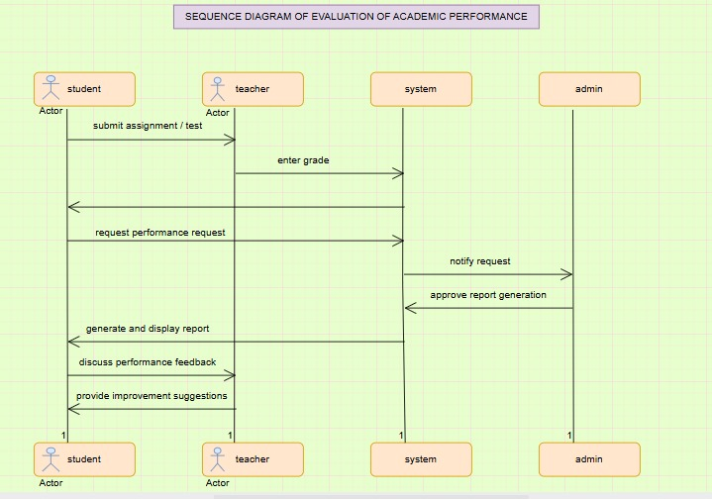

Result:

The sequence diagram was drawn successfully.